**Personnel Change - PI Guidance for reviewing a personnel change submitted on their behalf**

1) Following is an example of an email you will receive when someone submits on your behalf:

Your approval is required for a Personnel Change Request submission on the study referenced below.

Log into the InfoEd LLeRA Reviewer Dashboard to review and approve the submission:  [Reviewer Dashboard](https://era.llu.edu/WebPortal/Redirector.asp?RoutedStepID=5EF62DA8-EE46-4B5E-83F8-E55C56F87E3D)

**IRB #:**  5240079  
 **PI:**  Rodman, Deborah  
 **Sponsor:**    
 **Title:**  Test for Personnel change requests   
 **Submitted By:**  Tami Terry

Please contact us if you have any questions.

Thank you.

**Human Research and Compliance**  
 11219 Anderson Street . Loma Linda, CA 92354  
 (909) 558-4531 (voice) . [irb@llu.edu](mailto:irb@llu.edu)

2) Click on the Blue [Reviewer Dashboard](https://era.llu.edu/WebPortal/Redirector.asp?RoutedStepID=5EF62DA8-EE46-4B5E-83F8-E55C56F87E3D)

3) Review the Personnel change created on your behalf by clicking on either the blue wording Project Personnel (to click page by page) OR the blue PDF (entire document combined).

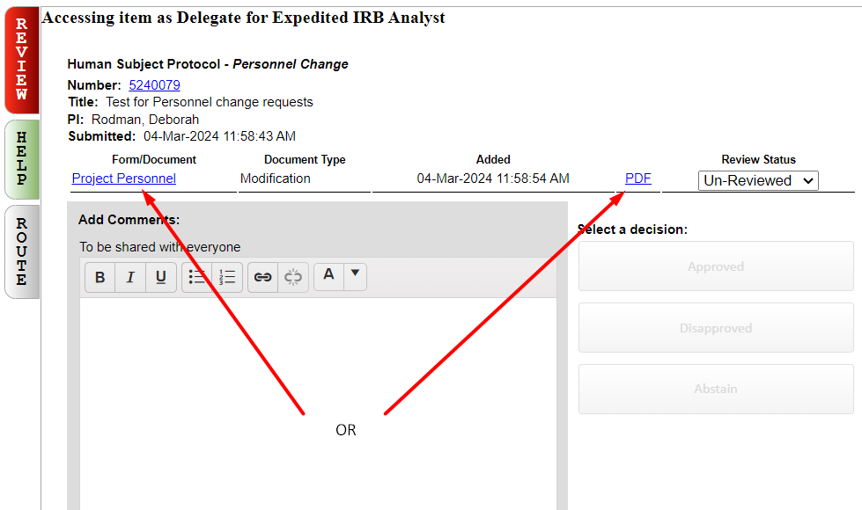

4) As you review, if you’d like to make comments, you may add them to the various boxes on the above screen.

5) When done reviewing the document, you can click on the X in the upper right corner.

6) Click on the Review Status pull-down and choose *Reviewed*.

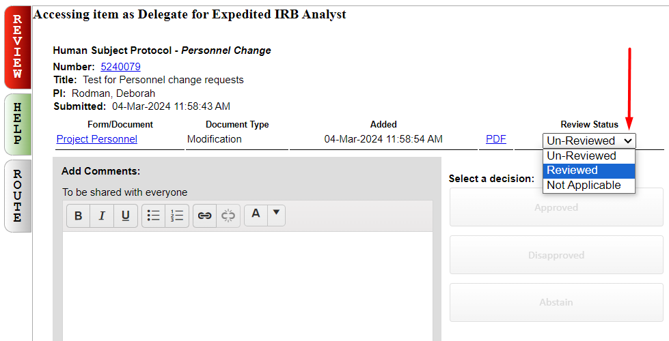

7) Under Select a decision, you may choose Approved or Disapproved; Abstain should not be used at this time.

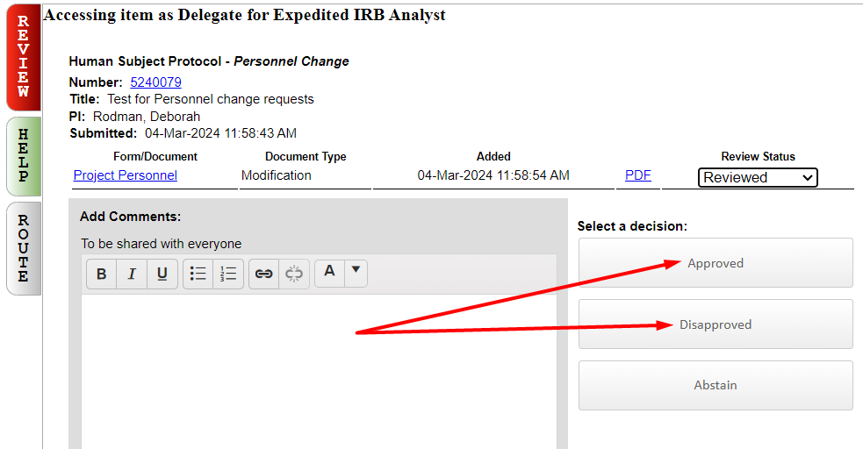

8) If you choose approved or disapproved, the below shows up – click one of the decisions to move on. If you forgot something, you can choose Cancel to go back and revise. Then continue the steps bringing you to this point, again.

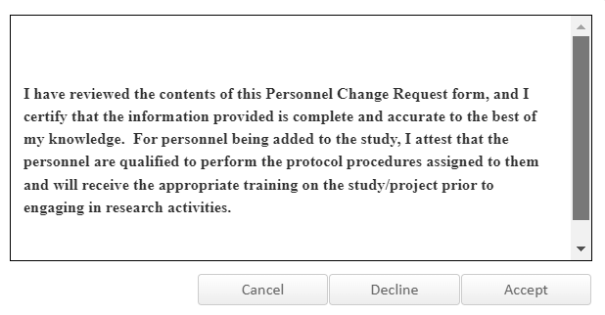



9) The screen refreshes to the below showing the decision and comments (if any).

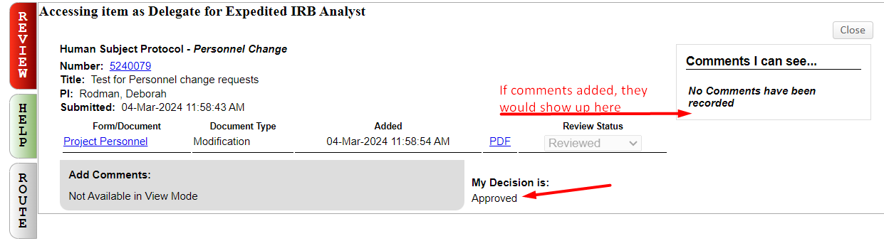

10) You may close this window. You should receive an email acknowledging receipt of your submission.

11) If you click on the blue wording in the email, you will see the following:

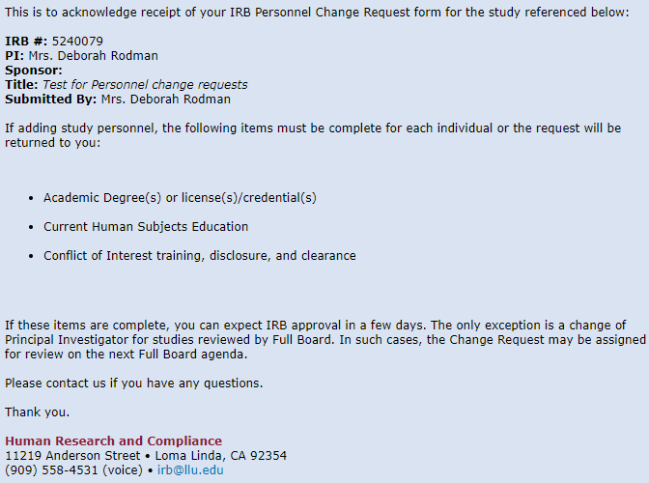

12) Your submission is now routed to HRC for review. You can close this window. If you are in the InfoEd record, you may close the study in the upper left corner by clicking on “Done” - (DO NOT click the X to close the study, as this leaves it open and running in the background).

13) Once approved, you will receive an official approval notice, via email.