Personnel-PI Change - General guidance for electronic submission

- If opening a study from era.llu.edu:
a. Log into InfoEd using your unique username and password.

- In the upper right corner, enter the IRB number of the study in the Quick Find – Enter

- Once that number populates the screen, follow the below guidance.
- Click on the IRB number
- Click on Create New
- Click on Personnel Change
- Go to #5 on this guidance document
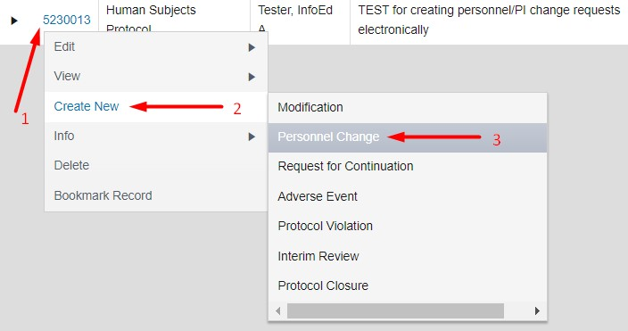

- If opening a study from the Investigator Portal “My Projects” tab:
  - Click on the icon under the IRB number
  - Click on Submissions in upper black bar
  - Click on pull-down arrow in upper right empty box
  - Click on Personnel Change
  - Click Add
  - Go to #5 on this guidance document

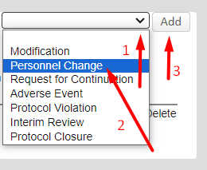

- Click on the blue Project Personnel under “Document/Form”
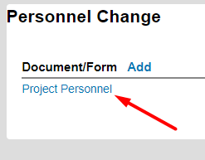

The form opens all pages as one file OR you may click on the section tabs at the top. The instructions below are per tab. Once activated, this form lasts the life of the study. Consequently, each time you add or remove personnel, this same form will open, for which you will need to uncheck the box by Complete in order to edit.

NOTE: All asterisked (*) fields must be completed

- Click on 1 - Summary tab
- Confirm the project summary in the first section is correct.
- Confirm submission type as Personnel Change
- Click all boxes YES or NO
- Briefly describe this personnel update – SAVE (upper right)
- Click on 2 - Instructions tab
- Look up HSRE and COI training dates using the link provided
- Look up SFI disclosure dates using the link provided
- Click on 3 - Project Personnel tab
- Click
- Type in name and click select in upper right
- Add role from the drop-down list
- Continue until all names are added – SAVE (upper right)
- To remove personnel, type today’s date in End Date box under their name
- When all End Dates are done – SAVE (upper right)

- Click on 4 - Obtaining Consent tab
- Follow instructions: If this is the first time you are completing this electronic form in InfoEd for this project, please add all existing personnel who are obtaining consent as well as any new personnel on this submission who will be obtaining consent.
- Add rows as necessary – SAVE (upper right)
- Click on 5 - Documents tab
a. Read question, complete each box – SAVE (upper right)
- Click on ALL PAGES tab – SAVE (upper right). Review for accuracy and make any applicable changes.

- Click Print box in upper right corner to save as PDF or print.

- Click Completed in upper right corner; Close

- Add any other forms/documents that may be used as support (if applicable)
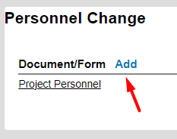

- If you need to make a change to the form prior to submission. Uncheck the box by Complete and make changes. Then Save and checkmark the box by Complete and close.

- Click Submit in the green box to the right.
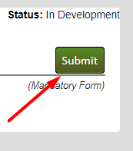
- Click the appropriate decision, then Continue:
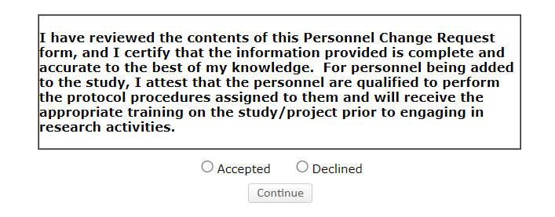
- Your submission is now routed for review. You can see the routing by clicking on either Show Current Route or (Route History):
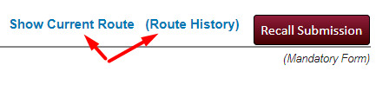
- If submitting on behalf of the PI, they will receive an email notifying them to review and approve this submission. If you are the PI, it is routed directly to HRC for review.
- If at this point you find that you need to make a change to the form, Click Recall Submission
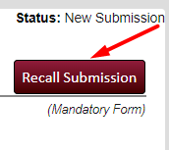
- Open the form, Uncheck the box by Complete, make changes and go forward again to Submit.
- You may close the study in the upper left corner by clicking on “Done” - (DO NOT click the X to close the study, as this leaves it open and running in the background).

