# **Submitting a Closure E-form**

## **Log into InfoEd**

1. For the production/live site, go to <https://era.llu.edu>
2. Your username and password are NOT connected to your standard LLUH login credentials. If you need help resetting your password, click “Having Trouble logging in?” If you do not know your InfoEd username, send an email to [irb@llu.edu](mailto:irb@llu.edu) for assistance. DO NOT use the same password for InfoEd that you use for LLUH logins.
3. **Important Note:** The InfoEd form utilizes a lot of pop-up windows. Please make sure your browser is set to allow pop-ups for the entire https://era.llu.edu domain.

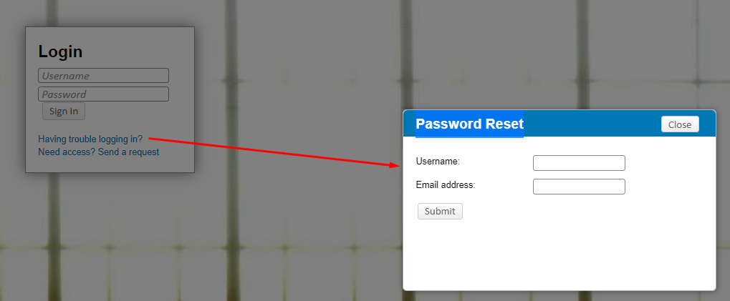

## **Create a Protocol Closure**

1. In the upper right corner, enter the IRB number of the study in the Quick Find – then click Enter
2. Once that number populates the screen, follow the below guidance.
3. Click on the IRB number
4. Click on Create New
5. Click on Protocol Closure

1. Click on the Final Report & Study Closure Form.

1. Then make sure that the “complete” button is unchecked and start filling out the form appropriately.

1. Once the form is completed, click on complete and then Submit

1. Accept the Certification and Click the Continue button.

1. Your submission is now routed for review. You can see the routing by clicking on either Show Current Route or (Route History):

1. If submitting on behalf of the PI, the PI will receive an email notifying them to review and approve this submission. If you are the PI, it is routed directly to IRB for review.
2. A red rectangle with white text

   AI-generated content may be incorrect.If at this point you find that you need to make a change to the form, Click Recall Submission
3. Open the form, Uncheck the box by Complete, make changes and go forward again to Submit.
4. You may close the study in the upper left corner by clicking on “Done” - (DO NOT click the X to close the study, as this leaves it open and running in the background).